

**School of Electrical Engineering (SELECT)**

**Fall Semester 2020 - 2021**

**EEE2004 – Measurement and Instrumentation**

**Project Based Learning (PBL) Report**

**Cash Counting Machine with UV-C Sanitation**

A project by

**Mangolik Kundu - 19BEE1101 -** [mangolik.kundu2019@vitstudent.ac.in](mailto:mangolik.kundu2019@vitstudent.ac.in)

**Souvik Datta - 19BEE1213 -** [souvik.datta2019@vitstudent.ac.in](mailto:souvik.datta2019@vitstudent.ac.in)

**Abstract** -

**‘Alcohol based Sanitizers don't work on surfaces like paper and cardboard’** and tend to damage them, this led a lot of people to question the possibility of the virus spreading through currency notes.

We aim to build a device which can sanitise currency notes by projecting Ultra Violet -C Light (UV-C) at them. Since, UV-C can alter the cell structure of COVID-19 virus, it can act as a promising step in diminishing the spread of the virus. Moreover it can act as a protective measure against any germs, bacteria and viruses.

UV-C Light of specifically 254 nanometre when concentrated on paper notes for a period of 10 minutes have shown to deactivate the virus.

***Reason to choose UV-C?*** Due to its shorter wavelength and tremendous energy capacity it makes an optimal disinfectant. “Previously, UV-C had also been effective in killing the **H1N1 Influenza** by causing lesions in its DNA and RNA structure, prohibiting it to replicate, thus effectively killing it”.

Cleaner notes can contain the spread of the virus, keeping in mind that cash is the primary mode of transaction among the masses and among any strata of life in India.

1. **Components Required** –

|  |  |  |  |
| --- | --- | --- | --- |
| **Serial No.** | **Component Name** | **Range/Type** | **Quantity** |
| 1 | Arduino UNO | Microcontroller | 1 |
| 2 | L293D IC | Motor Driver | 1 |
| 3 | DC Motor | Motors | 2 |
| 4 | LCD Display | Display | 1 |
| 5 | 10K Potentiometer | Regulator | 1 |
| 6 | IR Sensor | Range – 850nm | 1 |
| 7 | TCS-3200 Colour Sensor | Programmable colour-to-frequency converter | 1 |
| 8 | Breadboard | - | 1 |
| 9 | Jumper Wires | - | - |
| 10 | Micro-Push switch | Switch | 2 |
| 11 | Resistor – 220 ohm | Resistance | 6 |
| 12 | 2N2222 | Transistor | 1 |

1. **Circuit Diagram –**

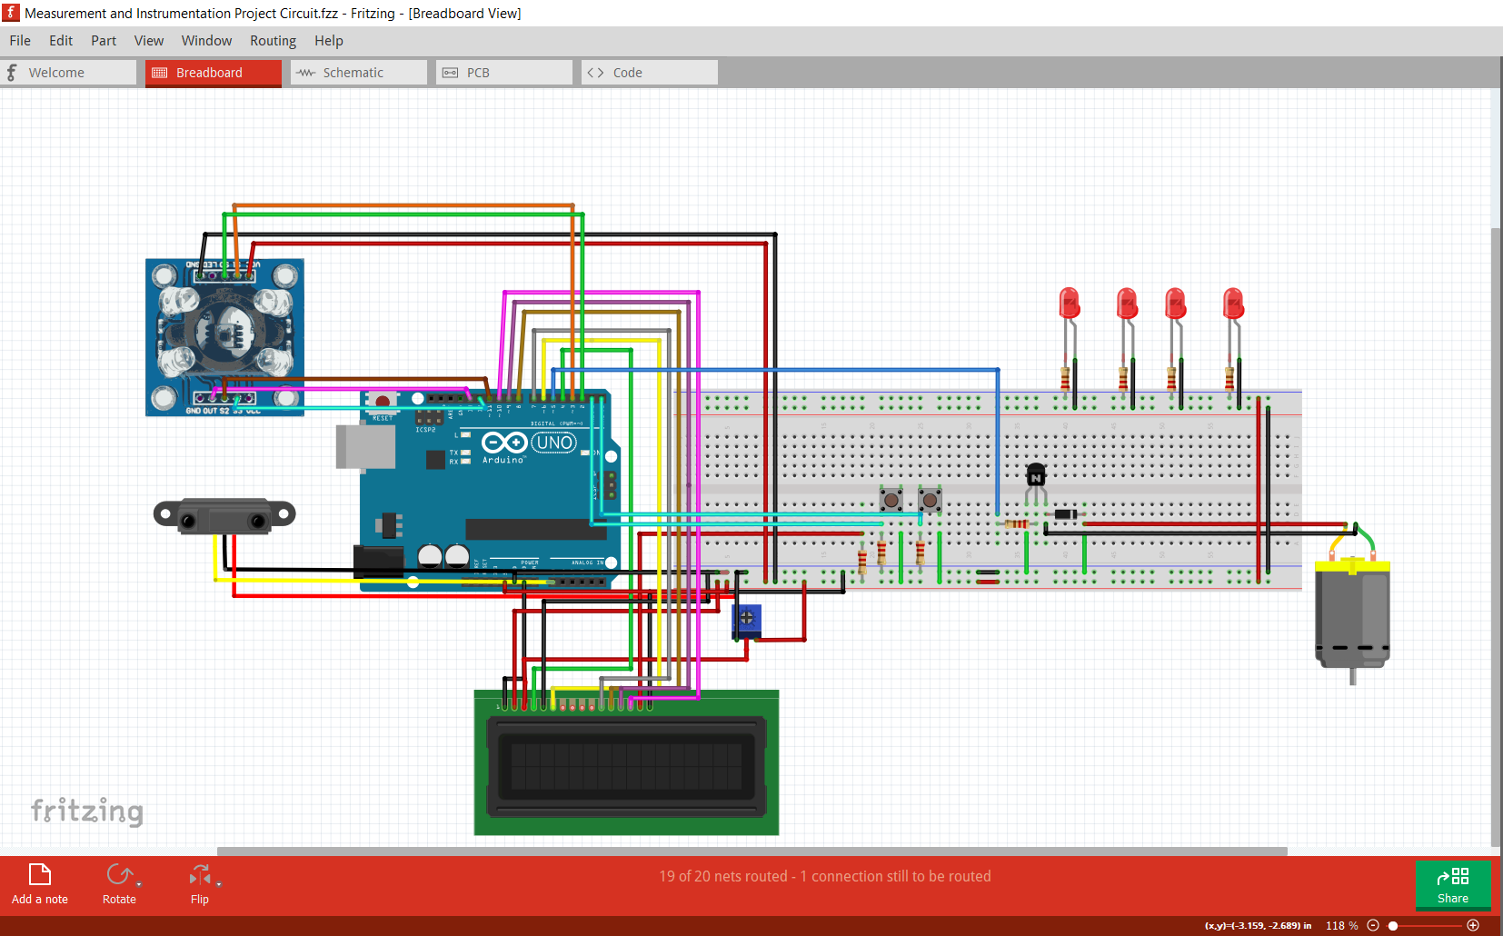

1. **Block Diagram for the complete process –**

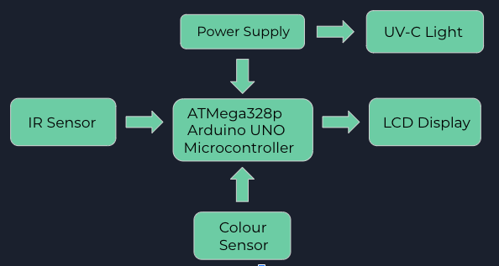

1. **Brief Description on Working** -

* Firstly, a set of notes is inserted into the machine.
* The **IR Sensor** is used to sense the presence of currency notes within a range of 850nm - The entire process is initiated with the activation of the IR Sensor, on the detection of the currency notes.
* On detecting motion, the main part of the code starts counting the number of notes with every change in motion.
* Once motion is detected, the **L293D Motor Driver**, creates an H-Bridge circuit and in this way two motors are driven simultaneously.
* Then the **TCS3200 - Colour Sensor** identifies each note using sensitive filters and sensor array perform the colour sensing by measuring the reflected wavelength.
* The code identifies each note and adds it’s value and the process continues for ‘N’ set of notes.
* After 1s the **LCD** displays the total number of detected notes.
* While the notes are being counted the **UV-LEDs** operate in the background, sanitizing them.

1. **Brief about the software used** – Arduino IDE is a special software that allows to write sketches (synonym for program in Arduino language) for different Arduino boards. The Arduino programming language is based on a very simple hardware programming language called processing, which is similar to the C language. After the sketch is written in the Arduino IDE, it should be uploaded on the Arduino board for execution.

A program written in the Arduino Programming Language is called sketch. A sketch is normally saved with the .ino extension (from Arduino).

The main difference from “normal” C or C++ is that the code is wrapped into 2 main functions. One is called setup(), the other is called loop(). The setup() is called once, when the program starts and the loop() is repeatedly called while the program is running.

The board features serial communication interfaces, including Universal Serial Bus (USB) on some models, which are also used for loading programs from personal computers.

We have also used Tinkercad for the development of the circuit simulation, although the circuit simulation does not account for the complete circuit due to limitation in availability of various components. I hereby attach the link for the circuit simulation on Tinkercad : <https://www.tinkercad.com/things/0HtwJjPm1x5-mi-project-/editel?sharecode=XXOrRg18AFTtH60Pw8-57gOHyCe6shPyg4V6DfhVQfc>

(Note: The following link can be accessed only if the user has a Tinkercad account.)

Last but not the least, we have used Fritzing for the development of the complete circuit diagram and schematic for the project.

1. **Output waveforms / Results –** On executing the circuit we can successfully count and identify the notes. The device can store the data and work like any other note counting machine and perform the same functions with UV-C sanitation.

**Snapshots of the circuit simulation –**

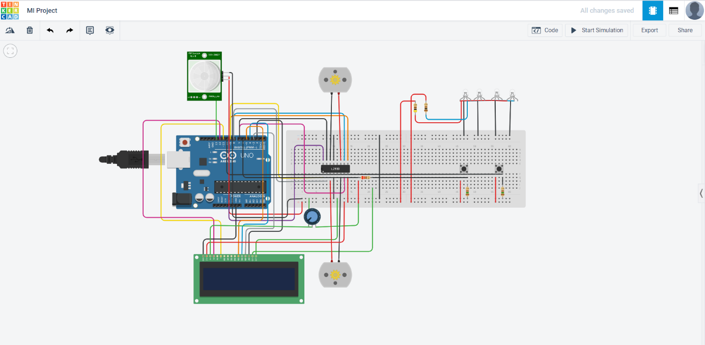

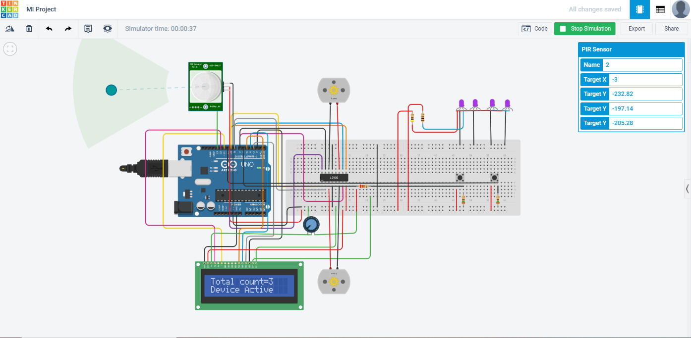

**Link for Hardware Video:**

[**https://drive.google.com/file/d/1a-FRCe2SWSdBBZ9lVP_QnfMxu_M4A0bY/view**](https://drive.google.com/file/d/1a-FRCe2SWSdBBZ9lVP_QnfMxu_M4A0bY/view)

**Link for Code:**

<https://drive.google.com/file/d/1I8DTCVtbaBrLxH8RMIfWXNTWH9POxems/view>

1. **Photograph of the Project Model –**

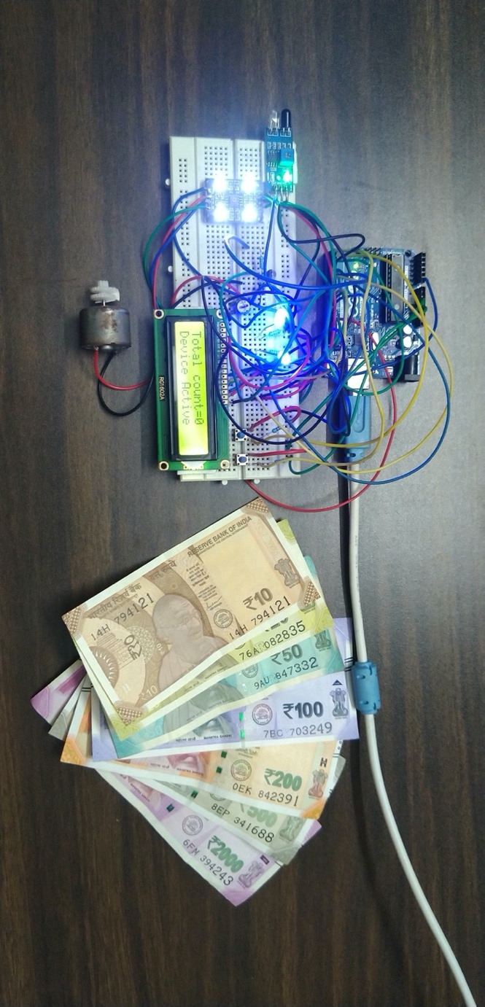

1. **Inferences obtained from the project** – On executing the circuit we can successfully count and identify the notes. The device can store the data and work like any other note counting machine and perform the same function while performing UV-C sanitation.
2. **Societal Impact of the project** - *“A study conducted in 2016 by Tirunelveli Medical. College, Tamil Nadu stated that 86.4% of 120 bank notes collected from doctors, banks, markets, butchers, students had various disease causing pathogens”* ***–*** ***A report published in the Journal of Current Microbiology and Applied Sciences.***

This device can attract numerous businesses which involve cash transactions, e.g. - Pharmacies and Banks, and pose a threat of contracting the virus. The device can find a huge application in public places like ‘Railway Stations & Hospitals’, where money gets exchanged from various hands.

In **ATMs** this module can be integrated with cash withdrawing as well as cash depositing machines so that customers as well as bank officials are free from worries of contracting COVID-19.

1. **Application(s) and Future scope of the project** –

* Help in containing the spread of the COVID-19 as well as all other forms of bacteria, germs and viruses with the help of UV-C sanitisation.
* Making hand-to-hand cash transactions more safe and hygienic.
* Even in the era of the digital world, cash transactions still make a huge part of the market transactions, thus it can have a huge positive impact on the society.
* It is a low cost device and people can use it to sanitise currency notes without any physical harm or fear of damaging the currency note.
* In **ATMs** this module can be integrated with cash withdrawing as well as cash depositing machines

1. **Conclusion –**

This project has the potential to find a future scope into a large market, as India is still heavily dependent on cash transactions. It can find widespread use in Banks and ATM machines.

As this is our first Arduino based project, thus in the development of the hardware as well as the software simulation part of the project we have learnt working on various components, their working principle, methodology of working and various troubleshooting techniques. The project helped us to grasp the working principle of the TCS3200 Colour sensor, Arduino UNO, IR based proximity sensor, various methods of interfacing the Arduino UNO with a motor. We have also learned on the two methods of interfacing the lcd display with the Arduino UNO – The I2C Connection and the normal 16 pin interfacing of the lcd display with the Arduino UNO.

1. **References –** 
   1. Darnell, M. Subbarao, K. et al (2004), “*Inactivation of the coronavirus that induces severe acute respiratory syndrome, SARS-CoV”,* Elsevier Public Health Emergency Collection, 2004 Oct; 121(1): Pg. 85–91. <https://www.ncbi.nlm.nih.gov/pmc/articles/PMC7112912/>
   2. Anderson, M. (2020) *“UV Light Might Keep the World Safe From the Coronavirus—and Whatever Comes Next”*, IEEE Spectrum <https://spectrum.ieee.org/biomedical/devices/uv-light-might-keep-the-world-safe-from-the-coronavirusand-whatever-comes-next>
   3. Buonanno, M. Welch, D. et al (2020),*“Far UV-C Light (222 nm) efficiently and safely inactivates airborne human coronaviruses”*, Scientific Reports <https://www.nature.com/articles/s41598-020-67211-2>
   4. Insight on the effectiveness of UV-C-*“In the race to find an effective solution that can sanitise large spaces from COVID-19, ultraviolet light seems to be a strong contender”* **-** <https://www.thequint.com/tech-and-auto/tech-news/is-uv-c-light-effective-against-coronavirus>